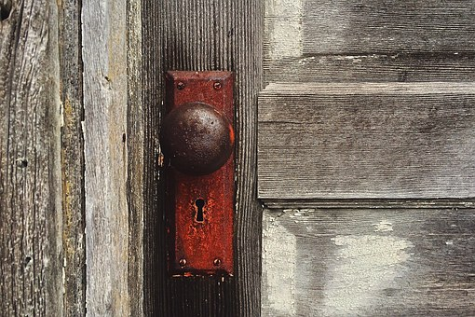

**THE BOOK OF REVELATION**

**“Behold, I stand at the door and knock; if any man**

**hear My voice, and open the door, I will come in to him…**

Revelation 3:20

**Time Stamps: Scriptural Timing Clues**

|  |  |
| --- | --- |
| **1. Pestilence, Famine, Sword/ Scatter/Captivity** | This is when the LORD scatters the 10 tribes (House of Israel) into this realm, “whoever leads into captivity will go into captivity, whoever kills by the sword, will die by the sword” |
| **2. Jacob’s Trouble: Tribulation/Short Time** | This is the Short Time after Satan is defeated in heaven and cannot return. This is after Christ’s ascension where Satan comes to the earth to persecute the nation of Israel – JACOB’S Trouble, not the world’s. He knows he is going to be bound in the Pit for 1,000 years and knows Jesus’s second coming is soon (the letters in the Book of Revelation prepares Jesus’s followers for what they had to do for the 1,000 year reign). They were fed to lions, crucified, tortured, burned alive, etc. Their reward is the 1,000 year reign and their martyrdom was also a testimony that was going to go out to the world. *We will be studying the Book of Maccabees to show case Antiochus Epiphanes and how he was utilized during Satan’s short time, along with the Book of Daniel |
| **3. Jesus’s 2nd Coming: Mt. Zion/ 1260/1290/1335 Days/New Song/Satan is Bound/Gospel Goes Out to the World** | 2nd Coming – during the time of John, Pergamum is Satan’s seat and will be destroyed, God shakes the earth mightily with Jesus’s second coming (I believe this is when the ancient ruins were turned into rubble). 1000 year Reign begins. The 1260/1290 /1335 are actually YEARS and the 1000 year reign begins the countdown of 1260/1290/1335. When the 100 year reign is over, there will be 260/290/335 years left (335 altogether, but broken down in these fragments. The realms are closed off to one another. During the 1000 year reign, the gospel goes out to this realm (to every tongue, tribe, nation) where the 10 tribes were scattered into the 4 corners of the earth, without a way back, but for the Messiah. |
| **4. Little Season: Trumpets/Bowls/Wrath,**  **Great Tribulation/Hour/**  **Time, Times, ½ Time/42 Months/Flood/Labor Pains** | This is a description of the time frame after Satan is released from the Pit to go out and deceive the world one last time. AFTER the 1,000 year reign: A lot is inside this time stamp! Clefts of the mountain is when every eye will see Jesus. |
| **5. Clefts of the Mountain/Gather/Harvest/6th Bowl/7th Trumpet/Thief** | This is not Jesus’s second coming. This is the gathering of GOD’s people in the 6th Bowl, before Armageddon. |
| **6. Armageddon** | The last few Bowls are preparation for Armageddon. In scriptures it looks like believers are taken before Armageddon and then the kings of the east (here), go there, (west) or Megiddo. |
| **7. 7th Seal and 7th Bowl/Destruction of the Earth** | The end of time: Silence for a half an hour and then a great earth quake like nothing ever before it. I believe this is where the destruction of the earth fits in the best! |
| **8. New Earth and New Heaven** | This realm will be destroyed, the other realm, where Zion is, will be made “new” and the New Jerusalem will come down from heaven. |
| **9. Latter Days/Tabernacle:** | God’s Kingdom: New Jerusalem |