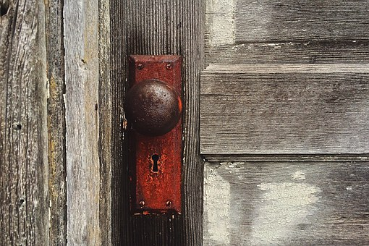 **Revelation**

**RECAP OF STUDIES 1-3 and A-Z**

1. There are seven seals, seven trumpets and seven bowls, what do the seven seals

do? ___________________________________________

2. What is the 7th Trumpet? ________________________.

3. What happens to the Euphrates River in the 6th Bowl and why?

_________________________________________________________

4. When you see the words the east, Assyria, Egypt, Babylon, what realm does it

refer to? ______________________________________

5. Who was scattered into this realm and never to return?

________________________________ Why?

_______________________________________

6. Why did God sacrifice for Adam and Eve, but once the 10 tribes were given the divorce certificate, God had to send a redeemer? ____________________________________________________________

7. What does the time stamp words, New Song in the scriptures stand for?

______________________________________.

8. When Jesus says in the scriptures, that He will come as a thief, we see that time

stamp terminology in what Bowl? _______________________. This is what Trumpet and again, what happens inside this Trumpet?

__________________________________________________________________

9. What is a serpent and what is a beast of the field in scriptures?

_________________________________________________.

10. Who are the three sons of Noah? __________________________________?

11. What does Ham do that causes Canaan (his baby) to be cursed?

_______________________

12. Who are the Israelites instructed to destroy from the face of earth?

__________________________________. Why?

_____________________________________________

13. Which realm is represented by the words holy land?

_____________________________________

14. Where does it look like Hades is located according to scripture?

____________________________________________

15. Was the second temple destroyed in 70 AD? ___________