
Revelation
GREECE

I. ALEXANDER THE GREAT (OF GREECE) DIES AND HIS EMPIRE IS SPLIT AMONGST HIS FOUR GENERALS/THE 4 WINDS OF HEAVEN:

Ptolemy – Egypt

Seleucid – Syria (Antiochus IV Epiphanes comes after Seleucid)

Cassander – Macedonia

Lysimachus – Thrace where eventually they established a kingdom called Pergamum

II. PERGAMUM

Revelation 2 – the seat of Satan
Revelation 9:11 Apollyon is Greek
The famous alter of Zeus – the great statue – Antiochus Epiphanes encouraged his people to worship him as Zeus or God Manifest

III. SEPTUAGINT: WRITTEN 300-200 BC

What is interesting is that GOD never uses the tribes of Ham or Japhet to punish Israel, GOD always uses a ‘brother’ or a direct line:

1. Abraham is a Chaldean, or Babylonian when he is asked to leave his family and land and go to a land that is GOD’s
2. Asshur is the son of Shem (the blood line of Abraham) and turns into the people of Assyria or Nineveh (the capital) that Jonah was told to preach to.
3. Greeks are the Galatians/Celts. They are utilized in the Book of Galatians, “²⁸ There is neither Jew nor Greek, there is neither bond nor free, there is neither male nor female: for ye are all one in Christ Jesus. ²⁹ And if ye be Christ's, then are ye Abraham's seed, and heirs according to the promise. What we must understand, is that there are MANY people groups of Abraham’s seed. He had children with three women: Sarah, Hagar and Keturah.

Septuagint is written in Greek
Galatians – Greeks/Celts: mercenaries
Luke is Greek
John the Revelator was on the island of Patmos. Greece.

IV. THE MACCABEES

These are people of the House of Judah living AFTER Christ ascended. I am going to prove that to you! They are the people who go through Satan’s ‘short time’ before he is bound for 1000 years. They will be trampled on by Greece – or what Daniel calls the male goat. During this time, the first mark of the Beast is instituted.

Revelation 2:12-13 “And to the angel of the church in Pergamos write, ‘These things says He who has the sharp two edged sword: I know your works , and where you dwell, where Satan’s throne is. And you hold fast to My name, and did not deny My faith even in the days in which Antipas was My faithful martyr, who was killed among you, where Satan dwells……. To put a stumbling block before the children of Israel House of Israel in the other realm, to eat things sacrificed to idols, and to commit sexual immorality. We are going to see what Antiochus Epiphanes does to GOD’s alter and His people.

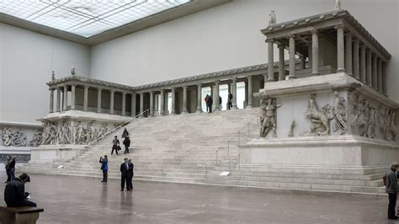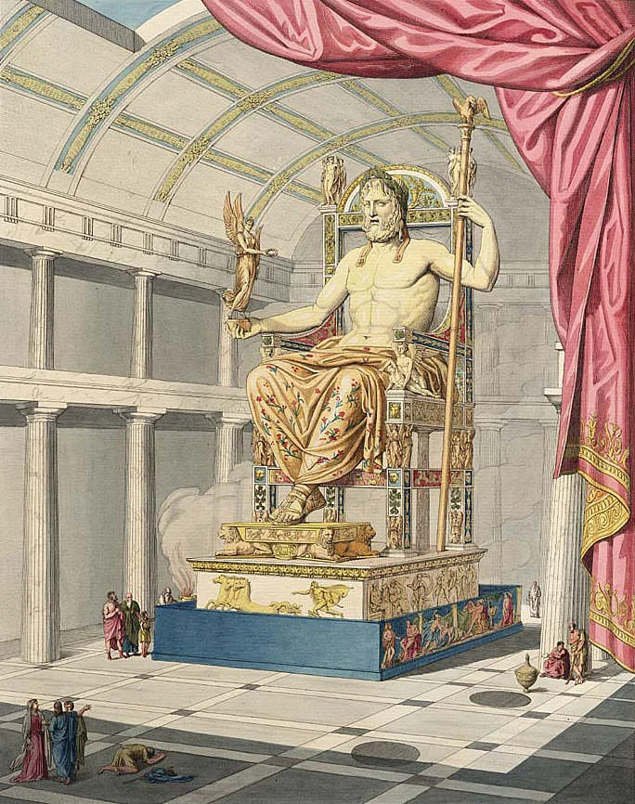

The alter of Zeus in Pergamum and there was also a statue. 2 Maccabees 6:1 Acts 14:8-13

