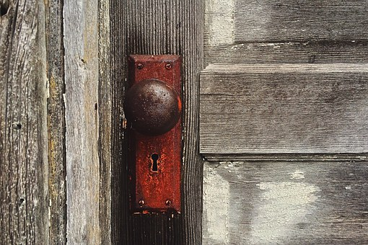
Revelation
FIGS AND THISTLES/BRIARS AND THORNS

Matt. 7:16 You will know them by their fruits. Grapes are not gathered from thorn bushes nor figs from thistles, are they?

Num. 33:55 But if you do not drive out the inhabitants of the land from before you, then it shall come about that those whom you let remain of them will become as pricks in your eyes and as thorns in your sides, and they will trouble you in the land in which you live.

Joshua 23:12-13 For if you ever go back and cling to the rest of these nations, these which remain among you, and intermarry with them, so that you associate with them and they with you, know with certainty that the Lord your God will not continue to drive these nations out from before you; but they will be a snare and a trap to you, and a whip on your sides and thorns in your eyes, until you perish from off this good land which the Lord your God has given you.

Isaiah 5:5-6 “So now let Me tell you what I am going to do to My vineyard:
I will remove its hedge and it will be consumed;
I will break down its wall and it will become trampled ground.
“I will lay it waste;
It will not be pruned or hoed,
But briars and thorns will come up.
I will also charge the clouds to rain no rain on it.”

Jer. 24:2 ² One basket had very good figs, like those that ripen early; the other basket had very bad figs, so bad they could not be eaten.

Judges 2:3-22 ³ Therefore I also said, ‘I will not drive them out before you; but they shall be thorns^{[a]} in your side, and their gods shall ^{[b]}be a snare to you.’ ” ⁴ So it was, when the Angel of the Lord spoke these words to all the children of Israel, that the people lifted up their voices and wept.

Hosea 9:6 For behold, they will go because of destruction;
Egypt will gather them up, Memphis will bury them.
Weeds will take over their treasures of silver;
Thorns will be in their tents.

Hebrews 6:7-8 For ground that drinks the rain which often falls on it and brings forth vegetation useful to those for whose sake it is also tilled, receives a blessing from God; but if it yields thorns and thistles, it is worthless and close to being cursed, and it ends up being burned.

Gen. 3:7 Then the eyes of both of them were opened, and they knew that they were naked; and they sewed fig leaves together and made themselves coverings.

Hos. 9:10 “I found Israel Like grapes in the wilderness; I saw your fathers As the first fruits on the fig tree in its first season. But they went to Baal Peor, And ^{[a]}separated themselves to that shame; They became an abomination like the thing they loved.

Matt. 24:32-34 ³² “Now learn this parable from the fig tree: When its branch has already become tender and puts forth leaves, you know that summer is near. ³³ So you also, when you see all these things, know that ^{[e]}it is near—at the doors!³⁴ Assuredly, I say to you, this generation will by no means pass away till all these things take place. ³⁵ Heaven and earth will pass away, but My words will by no means pass away.

Is. 55:12 For you shall go out with joy, and be led out with peace; the mountains and the hills shall break forth into singing before you, and all the trees of the field shall clap their hands. Instead of the thorn shall come up the myrtle tree; And it shall be to the LORD for a name, For an everlasting sign that shall not be cut off.

