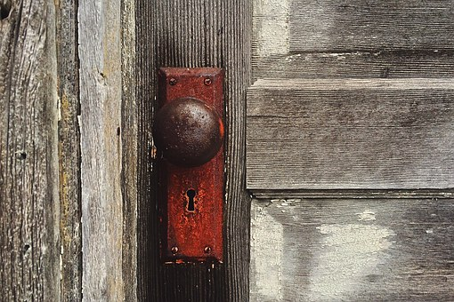
THE BOOK OF REVELATION
“Behold, I stand at the door and knock; if any man
hear My voice, and open the door, I will come in to him…

Revelation 3:20

3. Revelation Sheets Key:
Encoded Words & End Time Language

4 Corners/4 Winds: The four corners are the entire earth. The 4 Winds are the Spiritual realm which we cannot see.

Assyria: This is where the House of Israel is exiled to, which also becomes a parabolic word for this realm – and they are prophesied to never return until the end

Babylon/Woman/Harlot We are going to learn which land is Mystery Babylon!

Beast: Most powerful of the fallen angels

Beast of the Field: Fallen angels – and the field is Hades

Birds/Eagles: Angels

Branch/Root Jesus is the Branch or the Root and we are the vine

Bride: Jerusalem is a Bride and so are the people betrothed to Jesus

Captivity: The 10 Tribes (House of Israel)

Clefts/Sky Receded: Description or clue words for those who see Jesus after the Millennial Reign – when EVERY eye will see Him!

Cloud: Traveling in the Spiritual Realm

Coastlands: One of the realms that Mystery Babylon “trades” by ship

East: A realm

Egypt Sodom: Another term for a land that is lawless

Famine, Pestilence, Sword,
Captivity: The scattering of the 10 Tribes (House of Israel)

Figs and Thistles/Thorns: Wheat and Tares/Clay or Iron - the different seeds in the “harvest”

Flood: Wrath of GOD, plagues/tribulation – such as Egypt/Trumpets/Bowls

Gathering/Sickling: 7th Trumpet/Harvest

Gentiles: Another way to describe a realm

Gog/Magog/Megiddo: The other realm. Megiddo stands for Armageddon. The Euphrates will dry up between the two realms, opening them to each other for the first time since it was closed off for the Millennial Reign.

Grass/Dew: Grass are people and dew is the blessings of heaven.

Great City: Mystery Babylon

Greeks: One of the tribes included in the House of Israel (10 tribes)

Hail: Typically the wrath of GOD.

Harvest: 7th Trumpet/threshing/reaping – the gathering of GOD’s people and the gathering of those for GOD’s wrath

Head/Crowns/Horns: Head is mountains or Kingdoms, Crownsis power, Horns are ‘Kings’

Holy City: The New Jerusalem which comes down to Zion

Horses: Angelic army

Hour: GOD’s wrath or trial – Great Tribulation

House of Israel: 10 tribes out of the 12 that were exiled by Assyria/given the divorce certificate

House of Judah: 2 tribes out of the 12 that were exiled by Babylon - they are permitted to return and rebuild the second temple

In the Spirit: Without the body

Kings: Angelic leaders that are in powerful positions (rulers) of this realm - they look human.

Lampstands: Gatherings that the angels over-see – the letters are written to the angels, (not the ‘churches’) over the people who will go through Satan’s Short Time and Satan’s Little Season.

Lebanon: Another way to say Eden.

Locusts/Scorpions/Lions: Demonic entities

Merchants: Powers that “trade” with Mystery Babylon

Mountain: Kingdoms – sometimes called Heads

Naked/Ashamed: Sin

Nations: Realm clue: Ammon, Moab, Edom, etc.

King Nebuchadnezzar/
King Pharoah/King Tyre: Typologies of Satan/also described as ‘Kings’

New Song: GOD’s Kingdom (not the Millennial Reign of Jesus)

NSEW: Realm clues!

Offspring/Daughters: The people of GOD or of a land.

Oil/Wine: Oil and Wine: represents the temple

People, Tribes, Tongues: The entire earth

Residue: People who go through the Great Tribulation - the people who are born after the Millennial Reign begins.

Rod of Iron: Truth and Righteousness (Jesus rules with a Rod of iron)

Scatter: This is when GOD exiles the House of Israel to Assyria, into the four corners of the earth. They are prophesied to never return to Zion/Jerusalem, until the end

Sea Where Hades is – or under it.

Season: “Little Season” is Satan’s time after he is released from the Pit

Short Time: Satan’s time when Jesus ascends after crucifixion, and he is cast out of heaven and comes to earth for his ‘short time’ before he will be bound in the Pit for 1000 years, during the Millennial Reign.

Ships: Parabolic language for a type of transportation between the realms.

Stars: Angels

Thief: How Jesus describes Himself before the Harvest (not the second coming - the 7th Trumpet).

Tree: Can be people – but large trees are angels: Cedars are angels and the fig trees are people

Tribulation: Jacob’s Trouble during Satan’s Short Time, before he is bound (this is not Great Tribulation which is during Satan’s Little Season)

Trumpets: Great Tribulation – after Satan is released, his Little Season.

Tyre/Sidon: A physical place, but also a term to reference Hades

White Garments/Linen: Eternity

Wild Donkeys: Edom/Esau – who are also born of Abraham (Jacob’s fraternal twin brother). Jacob becomes Israel and Esau despises his birth right and is an enemy of GOD. Marries into the Canaanite women.

Wilderness: Realm language

World: Realm

Sword: Wrath of Jesus and Wrath of GOD

