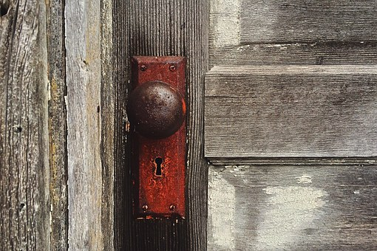
Revelation
1. SEEDS/SEEDS OF MEN

Psalm 89:25-29 Also I will set his hand over the sea,
And his right hand over the rivers.
²⁶ He shall cry to Me, ‘You are my Father,
My God, and the rock of my salvation.’
²⁷ Also I will make him My firstborn,
The highest of the kings of the earth.
²⁸ My mercy I will keep for him forever,
And My covenant shall stand firm with him.
²⁹ His seed we will be given to Yeshua also I will make to endure forever,
And his throne as the days of heaven.

Matt. 13:18-23 I added Matt, from the bottom of this sheet. This parable, as you are going to see, is predominately about the seed of the woman and the planting of the seed of the Word. ¹⁸ “Therefore hear the parable of the sower: ¹⁹ When anyone hears the word of the kingdom, and does not understand it, then the wicked one comes and snatches away what was sown in his heart. This is he who received seed by the wayside. ²⁰ But he who received the seed on stony places, this is he who hears the word and immediately receives it with joy; ²¹ yet he has no root in himself, but endures only for a while. For when tribulation or persecution arises because of the word, immediately he stumbles. ²² Now he who received seed among the thorns is he who hears the word, and the cares of this world and the deceitfulness of riches choke the word, and he becomes unfruitful. ²³ But he who received seed on the good ground is he who hears the word and understands it, who indeed bears fruit and produces: some a hundredfold, some sixty, some thirty.”

Ez. 17 And the word of the Lord came to me, saying, ² “Son of man, pose a riddle, and speak a parable to the house of Israel, ³ and say, ‘Thus says the Lord God:
“A great eagle with large wings and long pinions,
Full of feathers of various colors,
Came to Lebanon
And took from the cedar the highest branch.
⁴ He cropped off its topmost young twig
And carried it to a land of trade;
He set it in a city of merchants.
⁵ Then he took some of the seed of the land
And planted it in a fertile field;
He placed it by abundant waters
And set it like a willow tree.
⁶ And it grew and became a spreading vine of low stature;
Its branches turned toward him,
But its roots were under it.
So it became a vine,
Brought forth branches,
And put forth shoots.
⁷ “But there was another great eagle with large wings and many feathers;
And behold, this vine bent its roots toward him,
And stretched its branches toward him,
From the garden terrace where it had been planted,

II Sam 7:10 ⁵ “Go and tell My servant David, ‘Thus says the Lord: “Would you build a house for Me to dwell in? ⁶ For I have not dwelt in a house since the time that I brought the children of Israel up from Egypt, even to this day, but have moved about in a tent and in a tabernacle. ⁷ Wherever I have moved about with all the children of Israel, have I ever spoken a word to anyone from the tribes of Israel, whom I commanded to shepherd My people Israel, saying, ‘Why have you not built Me a house of cedar?’ ” ’ ⁸ Now therefore, thus shall you say to My servant David, ‘Thus says the Lord of hosts: “I took you from the sheepfold, from following the sheep, to be ruler over My people, over Israel. ⁹ And I have been with you wherever you have gone, and have ^{[a]}cut off all your enemies from before you, and have made you a great name, like the name of the great men who are on the earth. ¹⁰ Moreover I will appoint a place for My people Israel, and will plant them, that they may dwell in a place of their own and move no more; nor shall the sons of wickedness oppress them anymore, as previously, ¹¹ since the time that I commanded judges to be over My people Israel, and have caused you to rest from all your enemies. Also the Lord ^{[b]}tells you that He will make you a ^{[c]}house.

Dan. 2:43 ..they will mingle with the seed of men, but they will not adhere to one another, just as iron does not mix with clay.

