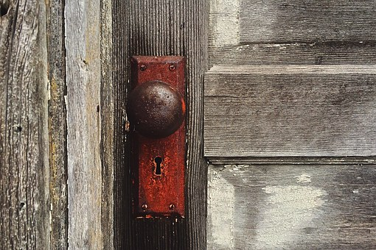
THE BOOK OF REVELATION
“Behold, I stand at the door and knock; if any man
hear My voice, and open the door, I will come in to him…

Revelation 3:20

Time Stamps: Scriptural Timing Clues

1. Pestilence, Famine, Sword/ Scatter/Captivity | These words represent when the LORD scatters the 10 tribes (House of Israel) into this realm.
2. Jesus is born, tells us who he came for and why, crucified, resurrected and ascends. Jesus enters the throne room as a lamb that had been slain. Satan is cast out of heaven. We are told this occurred 2026 years ago. We are going to learn that it was probably about 1300 years ago. | There is no time stamp language for these occurrences, but I wanted to you to see on the timeline where Jesus comes and starts the time clock.
3. Jacob’s Trouble: Tribulation/Short Time/The First Four Seals are Snapped out of the Seven! | This is the Short Time that begins when Satan is defeated in heaven and cast out as we are told in Revelation chapter 12. This is when Satan is cast to the earth and persecutes the nation of Israel or – otherwise called, JACOB’S Trouble, not the world’s. This is also marked by the word Tribulation - not Great Tribulation. Satan knows he is going to be bound in the Pit for 1,000 years (1000 means Millennial) and knows Jesus’s second coming is soon. Followers of Christ were fed to lions, crucified, tortured, burned alive, and died through many horrific ways of martyrdom. Their reward was the 1,000 year reign and their martyrdom was also going to be a testimony that was going to go out to the worlds or the realms.
4. Jesus’s 2nd Coming: Satan is Bound/Gospel Goes Out to the World/This is the Feast of Trumpets/Fifth Seal Is Snapped! Millennial Reign begins: starts the 1260/1290/1335 | Jesus’s 2nd Coming – during the time of John, Pergamum is Satan’s seat and will be destroyed, God shakes the earth mightily with Jesus’s second coming (I believe this is when the ancient ruins were turned into rubble throughout the world - Rome, Greece, etc.). 1000 year Reign begins. The 1260/1290 /1335 are actually YEARS and the 1000 year reign begins the countdown of those years! When the 1000 year reign is over, there will be 260/290/335 years left (but 335 years altogether, broken down in these fragments of years). The realms are closed off to one another during the 1000 year reign and the gospel goes out to this realm (to every tongue, tribe, and nation) where the 10 tribes were scattered into the 4 corners of the earth, without a way back to the other realm, but for the Messiah. We are going to see that the 5th Seal is for anyone who is martyred AFTER the Millennial Reign begins - and we are given a clue. This is their holding place.
5. Little Season: 1-5 Trumpets/1-5 Bowls/  Great Tribulation/Time, Times, ½ Time/42 Months/Labor Pains | These words are a description of the time frame when the Millennial Reign is over and Satan is released from the Pit to go out and deceive the earth one last time. Remember, after Jesus’s reign, there will be 260, 290 and 335 years. However, it’s 335 all together - which is called Satan’s Little Season!
6. Clefts of the Mountain/Gather/Harvest/6th Bowl and 6th Trumpet (Euphrates River)/Thief/This is the 7th Trumpet and the Sixth Seal is Snapped! | This is not Jesus’s second coming. This is the gathering or the harvest of GOD’s people, the wheat, and Satan’s seed, the tares, in the 6th Bowl, before Armageddon, which is the 7th Trumpet. Clefts of the mountain is when every eye will see Jesus.
7. Armageddon/Wrath: Destruction of the earth | The last few Bowls are preparation for Armageddon. In scriptures it looks like believers are taken before Armageddon and then the kings of the east (here), go to the other realm, (west), when the “Euphrates River” that runs between the two realms, dries and is prepared for the passage, mirroring the time when the Israelites were taken out of Egypt and GOD parted the Red Sea in order for them to leave. GOD gives dress rehearsals throughout scriptures - we just need to connect the dots. And then a great earth quake like nothing ever before it. I believe this is where the destruction of the earth fits in the best!
8. 7th Bowl: The Seventh Seal is Snapped! | Silence for a half an hour - and then this is the end of time. And GOD announces, “It is done!”
9. New Earth and New Heaven/New Song | This realm will be destroyed, the other realm, where Zion is, will be made “new” and the New Jerusalem will come down from heaven.
10. Latter Days/Tabernacle: | God’s Kingdom: New Jerusalem - when GOD ‘tabernacles’ or lives amongst us again like He did with Adam and Eve.

